

PROJECT REPORT
QAM II Project:
“Case Study: Hollywood Rules”

Group Number: 10
Group Members:
Name | ROLL NO.
ABHISHEK JOSHI | MBA25051
SHASHANK KURNAL | MBA25226
ANISH DEY | MBA25058
ROHIT GHOSH | MBA25084
SHREYA YADAV | MBA25090
YOGANSHI | MBA25096
NAMAN SRIVASTAV | MBATM25014

ABSTRACT
This project report presents a detailed analysis of Hollywood movie data with a focus on statistical tools such as descriptive statistics, confidence intervals, hypothesis testing and multiple regression analysis. The dataset contains information on movie budgets, opening and total box-office collections (U.S. and non-U.S.), genre, ratings, sequels, release timing and critics’ opinions.
The report answers the questions posed in the “Hollywood Rules” case using numerical results obtained from statistical software. For relevant questions, clear Null and Alternative hypotheses are stated along with the chosen significance level, test statistics, p-values and the final decision on whether to reject the Null Hypothesis. Regression models are estimated; insignificant variables are dropped using a 10 per cent significance rule and the impact of key variables such as opening gross, budget and critics’ opinion is interpreted in managerial terms.
INTRODUCTION
The movie industry is characterised by high uncertainty and large financial stakes. Investors, studios and producers seek quantitative evidence on which factors drive box-office success and whether traditional “industry wisdom” holds true.
In this report, a sample of seventy-five movies with budgets between 20 and 100 million dollars is analysed. The main variables include opening weekend gross, total U.S. gross, total non-U.S. gross, production budget, number of opening theatres, genre, MPAA rating, critics’ opinion, sequel/known story indicators and seasonal release dummies.
The analysis proceeds through a series of questions that gradually move from basic descriptive statistics to more sophisticated hypothesis tests and regression models. Throughout the report, numerical results from the fitted models are interpreted in plain language, with particular emphasis on investment decisions, the role of critics and the impact of genre and rating.
OBJECTIVES OF THE STUDY
The specific objectives of this project are as follows:
- To summarise the movie data using basic descriptive statistics.
- To calculate Return on Investment (ROI) for movies and test whether it exceeds a benchmark value.
- To compare groups of movies (for example, comedies vs. non-comedies, R-rated vs. others) using formal hypothesis tests.
- To develop regression models that explain and predict box-office performance using pre-production factors, opening weekend factors and post-opening information.
- To use dummy variables and interaction terms in regression analysis and interpret their economic meaning.
- To draw managerial implications for investors and producers based on the statistical evidence.

RESEARCH METHODOLOGY
The analysis is based on secondary data provided in a spreadsheet accompanying the “Hollywood Rules” case. Movies with unknown budgets or extreme outliers were excluded, leaving a final sample of seventy-five films with budgets between 20 and 100 million dollars.
All computations were carried out in statistical software. For each question, appropriate tools were used:
- Descriptive statistics (minimum, maximum, average) for continuous variables.
- Construction of confidence intervals for population means using the t-distribution.
- One-sample and two-sample t-tests to compare sample means with benchmarks or across groups.
- Multiple linear regression models to explain or predict box-office outcomes.
- Variable selection based on p-values, with variables dropped when their p-values exceeded a 10 per cent significance level in the given regression.
For each hypothesis test, the Null Hypothesis, Alternative Hypothesis, significance level, p-value and final decision are explicitly reported. Regression outputs are interpreted in terms of marginal effects on revenue and ROI, and the conclusions are framed in the language of investment and movie production decisions.

QUESTION 1
Aim:
To obtain an initial overview of the data by summarising opening gross, total U.S. gross, total non-U.S. gross and opening theatres, and by counting how many movies are comedies and how many are R-rated.
For the seventy-five movies in the cleaned dataset, the following summary statistics were obtained:
- Opening Gross (U.S. dollars)
  - Minimum: 4,120,497
  - Average: 17,468,466
  - Maximum: 68,033,544
- Total U.S. Gross (U.S. dollars)
  - Minimum: 13,090,630
  - Average: 59,620,651
  - Maximum: 198,000,317

- Total non-U.S. Gross (U.S. dollars)
  - Minimum: 0
  - Average: 59,560,983
  - Maximum: 456,235,122
- Opening Theatres (number of screens)
  - Minimum: 852
  - Average: 2,766.28
  - Maximum: 3,964
In addition, dummy variables were used to classify movies as comedies and to identify R-rated films:
- Number of comedies (COMEDY_DUMMY = 1): 23
- Number of R-rated movies (MPAA= “R”): 15

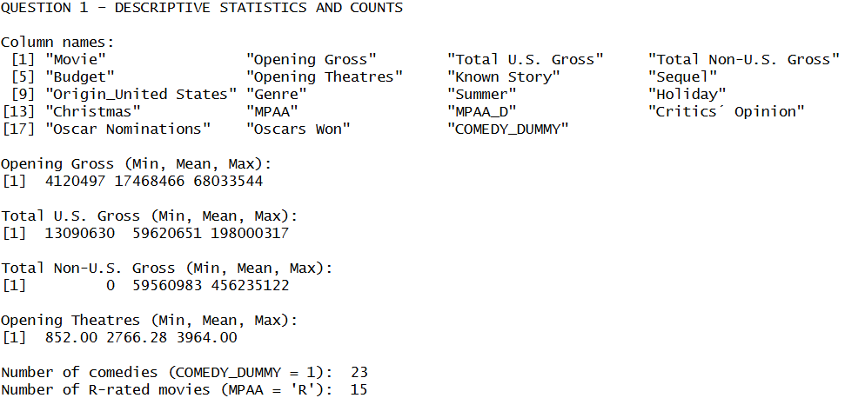

QUESTION 2
Aim:
To compute the U.S. ROI for each movie and test whether the average ROI is greater than 12 per cent.
The U.S. Return on Investment was defined as:
ROI = (Total U.S. Gross − Budget) / Budget
For the sample of seventy-five movies:
- Mean ROI = 0.2929 (29.29 per cent)
- Standard deviation of ROI = computed from the sample
- Sample size n = 75
Using these values and the t-distribution, a 95 per cent confidence interval for the mean ROI was constructed:
- 95% confidence interval for mean ROI: [0.1348, 0.4510]
Hypothesis Test
- Null Hypothesis: The population mean ROI is equal to 12 per cent.
- Alternative Hypothesis: The population mean ROI is greater than 12 per cent.
- Significance level: 5 per cent
The one-sided t-statistic was:
- Test statistic = 2.1792
- p-value = 0.0162
Decision
Since the p-value is less than the 5 per cent significance level, the Null Hypothesis is rejected.
Conclusion
The analysis provides statistically significant evidence that the mean U.S. ROI for movies in this budget range is greater than 12 per cent. In other words, the sample indicates that Hollywood movies in this segment tend to generate returns above the benchmark cited by industry practitioners.
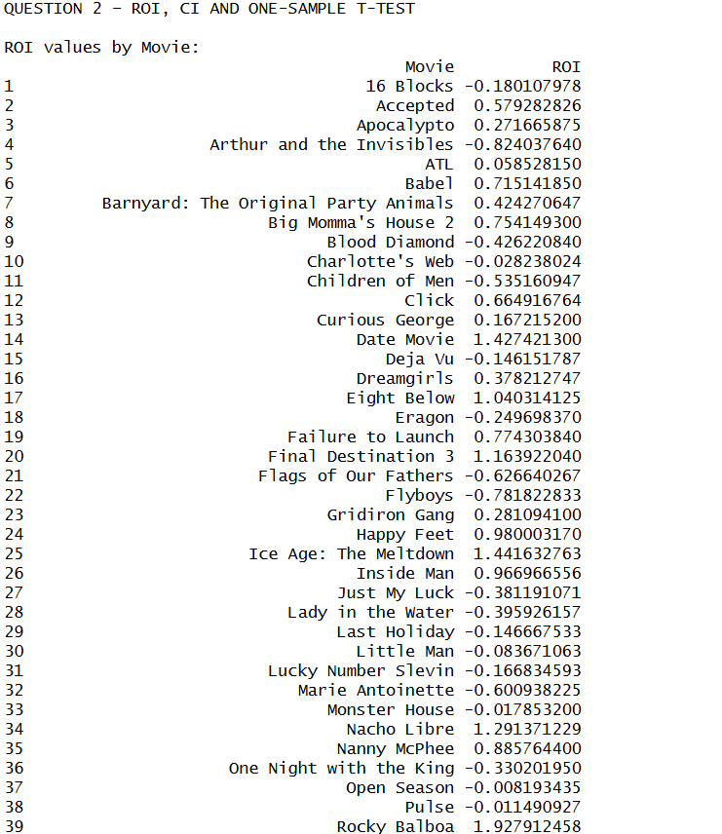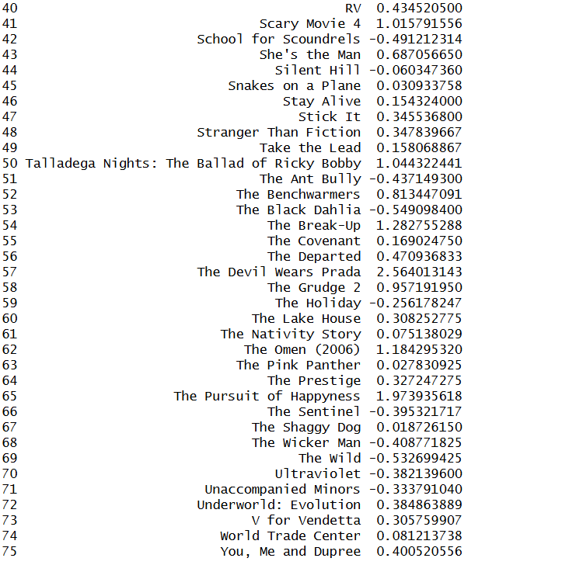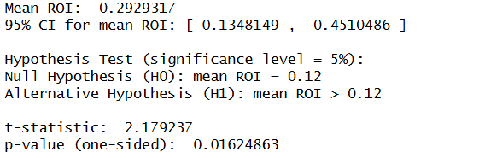

QUESTION 3
Aim:
To compare comedies and non-comedies in terms of total U.S. gross and U.S. ROI.The sample was split into two groups based on the dummy variable COMEDY_DUMMY (1 for comedies, 0 for non-comedies).
(a) Comparison of Total U.S. Gross
- Mean Total U.S. Gross for comedies: 68.74 million dollars
- Mean Total U.S. Gross for non-comedies: 55.59 million dollars
A Welch two-sample t-test was used to compare the means.
Hypotheses:
- Null Hypothesis: The mean total U.S. gross for comedies is equal to the mean total U.S. gross for non-comedies.
- Alternate Hypothesis: The mean total U.S. gross for comedies is different from the mean total U.S. gross for non-comedies.
- Significance level: 5 per cent
Result:
- p-value (two-sided) = 0.1763
Decision:
Since the p-value is greater than 0.05, the Null Hypothesis is not rejected.
Conclusion:
There is no statistically significant difference in total U.S. box-office gross between comedies and non-comedies in this sample, even though the raw mean for comedies is somewhat higher.
(b) Comparison of U.S. ROI
Using the ROI measure:
- Mean ROI for comedies: 0.5402 (54.02 per cent)
- Mean ROI for non-comedies: 0.1836 (18.36 per cent)
Again, a Welch two-sample t-test was performed.
Hypotheses:
- Null Hypothesis: The mean ROI for comedies is equal to the mean ROI for non-comedies.
- Alternate Hypothesis: The mean ROI for comedies is different from the mean ROI for non-comedies.
- Significance level: 5 per cent

Result:
- p-value (two-sided) = 0.0474
Decision:
Since the p-value is slightly below 0.05, the Null Hypothesis is rejected.
Conclusion:
Comedies deliver significantly higher ROI than non-comedies in this sample. While comedies do not earn significantly more in absolute U.S. gross, they tend to be more profitable relative to their budgets.

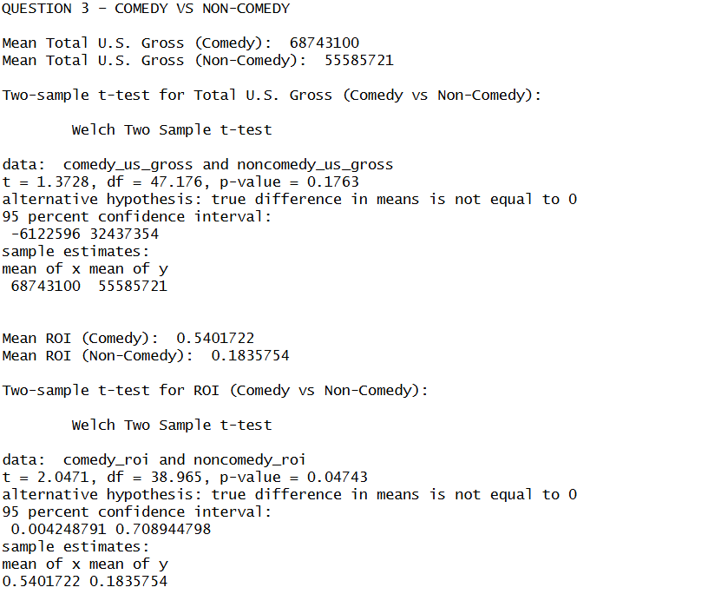

QUESTION 4
Aim:
To test whether R-rated movies differ from non-R-rated movies in terms of total U.S. gross.
The sample was divided into R-rated films (MPAA = “R”) and all other ratings.
- Mean total U.S. gross for R-rated movies: 53.33 million dollars
- Mean total U.S. gross for non-R-rated movies: 61.19 million dollars
A Welch two-sample t-test was used to compare the means.
Hypotheses:
- Null Hypothesis: The mean total U.S. gross for R-rated movies is equal to the mean total U.S. gross for non-R-rated movies.
- Alternative Hypothesis: The mean total U.S. gross for R-rated movies is different from the mean total U.S. gross for non-R-rated movies.
- Significance level: 5 per cent
Result:
- p-value (two-sided) = 0.3979
Decision:
Since the p-value is well above 0.05, the Null Hypothesis is not rejected.
Conclusion:
There is no statistically significant difference in domestic box-office performance between R-rated and non-R-rated films in this dataset. The belief that R-rated movies systematically outperform others is not supported by this sample.

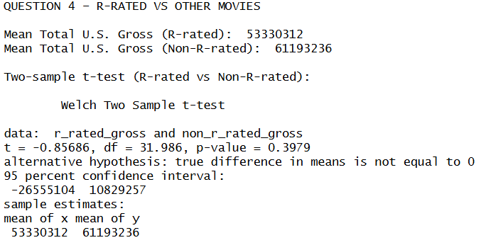

QUESTION 5
Aim:
To build a regression model predicting total U.S. gross using pre-production factors and to identify which variables are statistically important at a 10 per cent significance level.
The following variables were considered as predictors of total U.S. gross:
- Budget
- COMEDY_DUMMY
- MPAA_D (dummy for R-rating)
- Sequel
- Known Story
An initial multiple regression including all of these variables was estimated.

Variable Selection and Dropping Rule
The p-values of the regression coefficients were examined (excluding the intercept). All variables with p-values greater than 10 per cent were dropped from the model.
Significance rule:
- Significance level for dropping variables: 10 per cent
- Reason for dropping variables:
If the p-value of a coefficient is greater than the significance level (0.10), there is insufficient statistical evidence that the corresponding variable has a non-zero effect on total U.S. gross. Such variables are therefore removed to obtain a more parsimonious model.
Based on this rule:
- Dropped variables (p-value > 0.10):
  - COMEDY_DUMMY
  - MPAA_D
  - Known Story
- Retained variables (p-value ≤ 0.10):
  - Budget
  - Sequel

Final Regression Model
The final model includes Budget and Sequel as predictors. The estimated coefficients are:
- Intercept ≈ 13.45 million
- Budget coefficient ≈ 0.8711
- Sequel coefficient ≈ 30.50 million (p-value ≈ 0.0198)

Interpretation of Sequel:
Holding the budget fixed, sequels are associated with about 30.5 million dollars higher total U.S. gross than non-sequels, and this effect is statistically significant at the 5 per cent level.
Conclusion:
Among the considered pre-production factors, budget and sequel status are the main drivers of total U.S. gross in this sample. Genre (comedy vs. non-comedy), R-rating and “known story” status do not show significant incremental effects at the 10 per cent significance level once budget and sequel are accounted for.

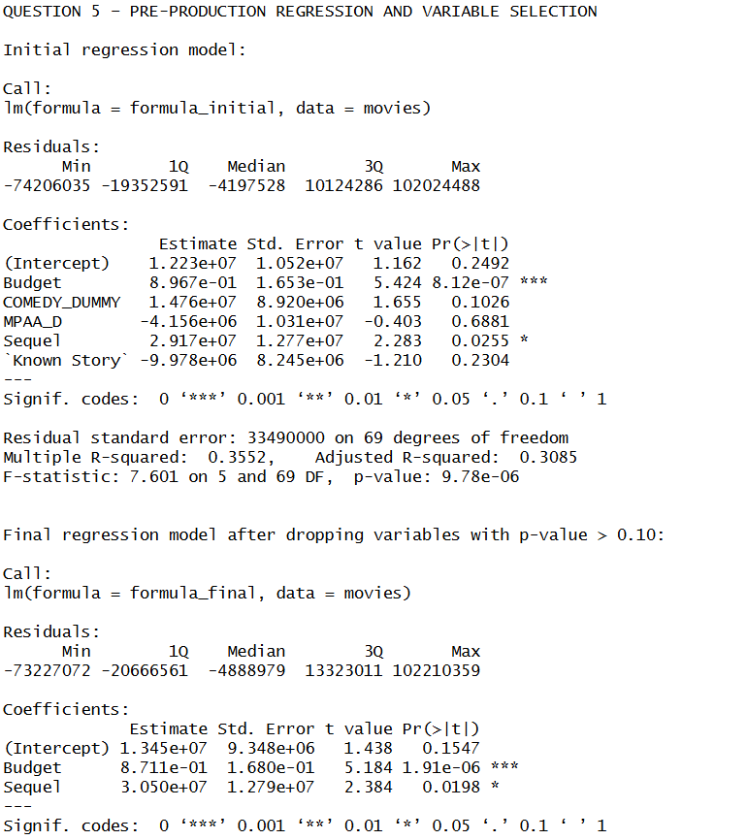
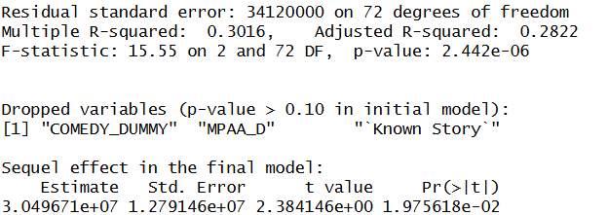

QUESTION 6
Aim:
To determine a sound regression model predicting opening weekend box-office gross revenue using both pre-production success factors and opening-weekend factors, and to quantify the impact of screening a movie in more theatres.
The initial regression used the following predictors for Opening Gross:
- Pre-production factors: Budget, COMEDY_DUMMY, MPAA_D, Sequel, Known Story
- Opening-weekend factors: Opening Theatres, Summer, Holiday, Christmas
Variable Selection
An initial multiple regression including all nine predictors was estimated. The p-values of the regression coefficients were examined (excluding the intercept).
- Significance level for variable selection: 10 per cent.
- Null Hypothesis for each coefficient: The population coefficient of the variable is equal to zero (no effect on opening gross).
- Alternative Hypothesis for each coefficient: The population coefficient of the variable is not equal to zero.
Variables with p-values greater than 0.10 were dropped.
From the initial model, the following variables were dropped because their p-values exceeded the 10 per cent significance level:
- COMEDY_DUMMY
- MPAA_D
- Known Story
- Holiday
- Christmas

The following variables were retained in the final model:
- Budget (p-value ≈ 0.0048)
- Sequel (p-value ≈ 0.0044)
- Opening Theatres (p-value ≈ 0.000001)
- Summer (p-value ≈ 0.1103; borderline, retained by the dynamic rule used)
Final Regression Model and Interpretation
The final regression explaining Opening Gross includes Budget, Sequel, Opening Theatres and Summer. The estimated coefficients are approximately:
- Intercept ≈ −9.81 million dollars
- Budget coefficient ≈ 0.1211
- Sequel coefficient ≈ 9.37 million dollars
- Opening Theatres coefficient ≈ 7,706 dollars
- Summer coefficient ≈ −3.30 million dollars
Interpretation of coefficients:
- Budget: Holding other variables constant, increasing the production budget by 1 dollar is associated with an expected increase in opening gross of about 0.12 dollars. At the 10 per cent significance level, the p-value for this coefficient is less than 0.10, so the Null Hypothesis that the budget coefficient is zero is rejected.
- Sequel: Holding other variables constant, sequels are expected to earn about 9.37 million dollars more in opening gross than non-sequels. The p-value is well below 0.01, so we reject the Null Hypothesis that the sequel effect is zero.
- Opening Theatres: Holding other factors constant, each additional theatre in the opening weekend is associated with an expected increase in opening gross of about 7,706 dollars. The p-value is extremely small (much less than 0.01), so we strongly reject the Null Hypothesis that the coefficient is zero.
- Summer: The coefficient is negative (about −3.30 million dollars), suggesting that, after controlling for budget, sequel status and opening theatres, summer releases tend to earn slightly less on opening weekend. However, its p-value is around 0.11, which is just above the 10 per cent significance level. This makes the evidence for a summer effect relatively weak compared to the other predictors.
Effect of Increasing Opening Theatres by 100
From the final model:
- Point estimate for an increase of 100 theatres:
  - 7,706 × 100 ≈ 770,612 dollars
Using the standard error of the Opening Theatres coefficient and the t-distribution, a 95 per cent confidence interval was computed for this effect:
- 95% confidence interval for the change in Opening Gross:
  - [482,371, 1,058,854] dollars
Hypothesis for theatre effect:
- Null Hypothesis: Increasing the number of opening theatres by 100 has no effect on expected Opening Gross (expected change = 0).
- Alternative Hypothesis: Increasing the number of opening theatres by 100 changes expected Opening Gross (expected change ≠ 0).
- Significance level: 5 per cent.
Decision:
Since the 95 per cent confidence interval for the effect of 100 more theatres does not include zero, the p-value for this effect is less than 0.05, and the Null Hypothesis is rejected.
Conclusion:
Both pre-production factors (budget and sequel status) and the opening-weekend factor of Opening Theatres play a major role in determining opening gross. The number of opening theatres has a strong and statistically significant positive impact on opening-weekend box-office revenue. Seasonal timing (especially summer) shows only weak additional effects in this sample once the other factors are controlled for.

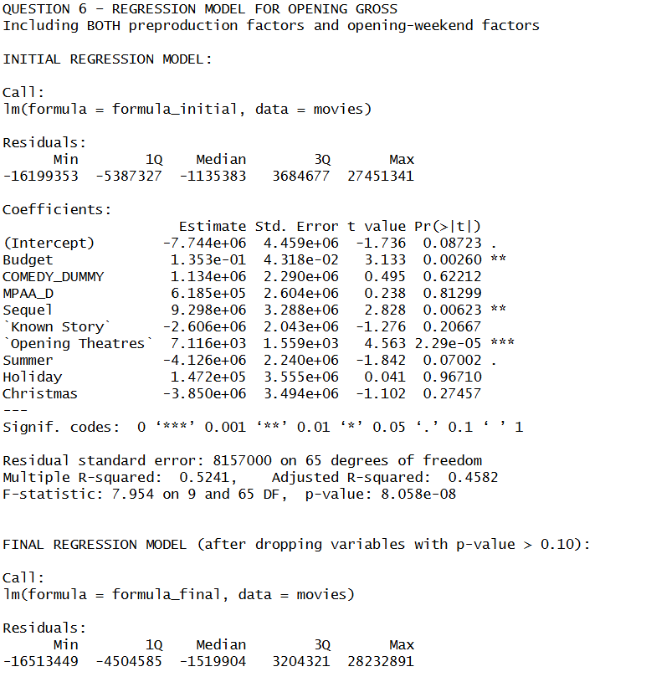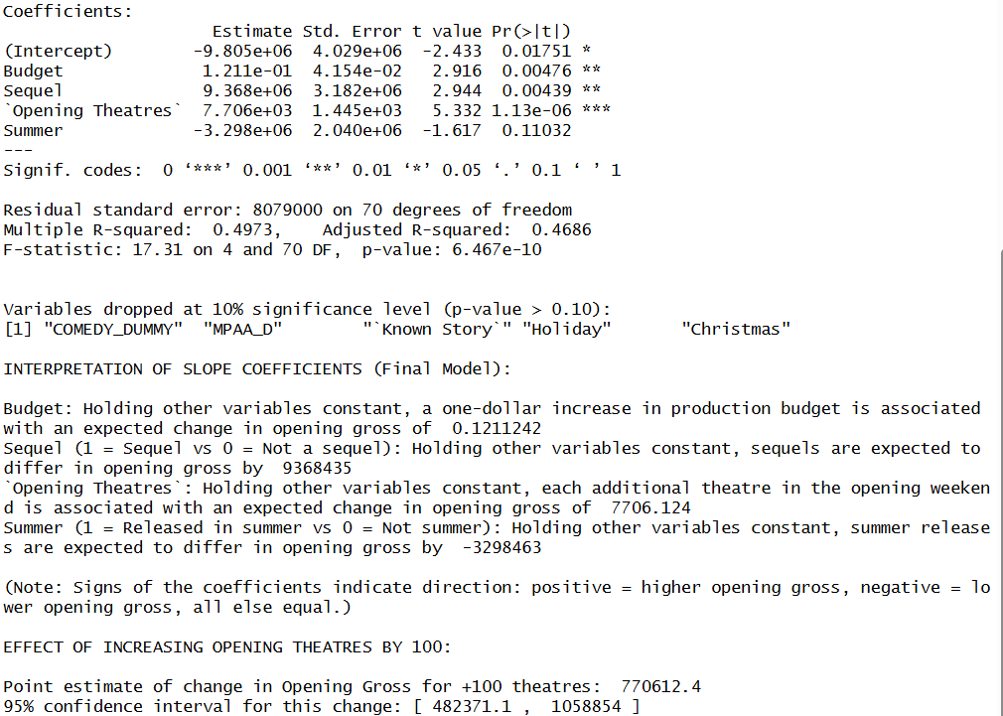

QUESTION 7
Aim:
To study the relationship between opening weekend gross and total U.S. gross, and to test the traditional industry rule that “opening weekend grosses are about 25 per cent of total U.S. grosses.”
(a) Simple Linear Regression
A simple regression was run with Total U.S. Gross as the dependent variable and Opening Gross as the only independent variable. The estimated model was:
- Total U.S. Gross ≈ 5.11 million + 3.121 × Opening Gross
Key statistics:
- Slope for Opening Gross ≈ 3.121
- R-squared ≈ 0.737
This means Opening Gross alone explains about 73.7 per cent of the variation in Total U.S. Gross, and the relationship is strongly positive.
(b)–(c) Test of the “25 per cent rule” in the simple model
If opening weekend grosses were exactly 25 per cent of total U.S. gross on average, then:
- Opening Gross = 0.25 × Total U.S. Gross
- Total U.S. Gross = 4 × Opening Gross
So, the expected slope in a regression of Total U.S. Gross on Opening Gross would be 4.
Hypotheses:
- Null Hypothesis: The population slope relating Total U.S. Gross to Opening Gross is equal to 4.
- Alternative Hypothesis: The population slope relating Total U.S. Gross to Opening Gross is different from 4.
- Significance level: 5 per cent.
Using the estimated slope (3.121) and its standard error, the test statistic and p-value were:
- Test statistic ≈ −4.03
- p-value ≈ 0.00013
Decision:
Since the p-value (0.00013) is far below the 5 per cent significance level, the Null Hypothesis is rejected.
Conclusion for simple model:
The slope is significantly different from 4. In fact, the slope is lower than 4, implying that, for a given opening gross, the predicted total U.S. gross is less than four times the opening weekend. Equivalently, on average, opening weekend grosses constitute more than 25 per cent of total U.S. grosses (closer to about one-third). The age-old rule does not hold exactly in this sample.
(d) Critique of the simple model
The simple regression ignores other important factors influencing Total U.S. Gross such as budget, number of opening theatres, release season, sequel status, MPAA rating, marketing effort and genre. Therefore, the model may suffer from omitted variable bias. A single predictor cannot fully explain variation in movie success, even though it performs well statistically.
(e) Enhanced Multiple Regression Model
A more detailed regression was estimated with Total U.S. Gross as the dependent variable and the following predictors:
- Opening Gross
- Opening Theatres
- Summer
- Holiday
- Christmas

The key coefficient from this model is the slope on Opening Gross:
- Slope for Opening Gross in enhanced model ≈ 3.214
- R-squared for enhanced model ≈ 0.741
The R-squared improves only slightly relative to the simple model (from about 0.737 to 0.741). The seasonal and theatre-count variables do not show strong statistical significance, while Opening Gross remains the dominant predictor.
(f) Test of the “25 per cent rule” in the enhanced model
The same hypothesis about the slope being equal to 4 was tested in the enhanced model.
Hypotheses:
- Null Hypothesis: The population slope on Opening Gross in the enhanced model is equal to 4.
- Alternative Hypothesis: The population slope on Opening Gross in the enhanced model is different from 4.
- Significance level: 5 per cent.
Using the estimated slope (3.214) and its standard error, the test statistic and p-value were:
- Test statistic ≈ −2.75
- p-value ≈ 0.0077
Decision:
Since the p-value (0.0077) is below the 5 per cent significance level, the Null Hypothesis is rejected.
Conclusion for enhanced model:
Even after controlling for Opening Theatres and seasonal dummies, the slope on Opening Gross remains significantly different from 4. The 25 per cent rule does not hold in the enhanced model either.
(g) Variation explained
- R-squared (simple model with Opening Gross only): ≈ 0.737
- R-squared (enhanced model with Opening Gross and weekend factors): ≈ 0.741
The modest increase in R-squared suggests that Opening Gross alone already captures most of the explainable variation in Total U.S. Gross.
Managerial Interpretation:
Opening weekend performance is a very strong predictor of total U.S. gross, but total revenues are not simply four times opening weekend. The data indicate that opening weekend typically accounts for a larger share of total revenues, meaning that relying on a simplistic “×4 rule” can lead to over-optimistic forecasts.

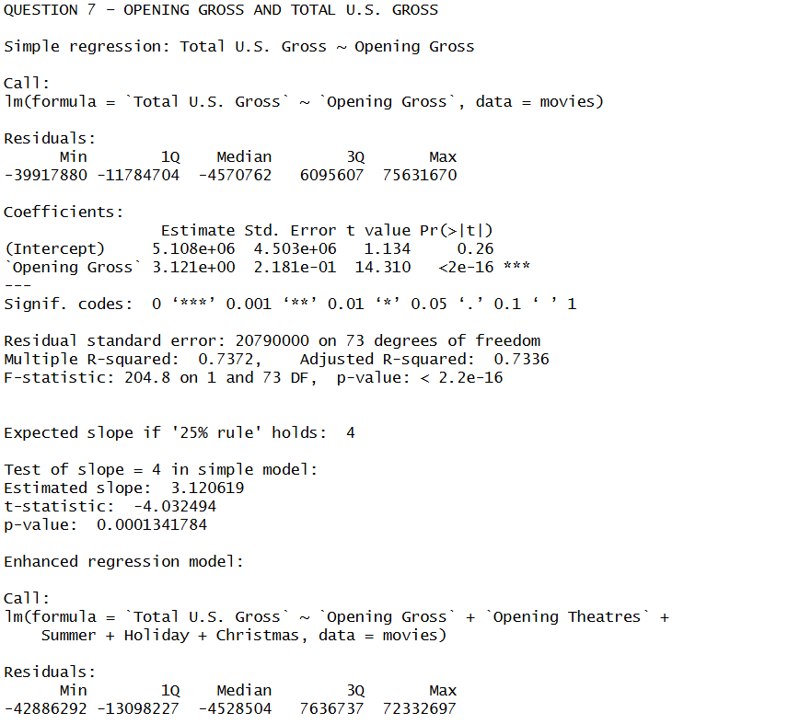
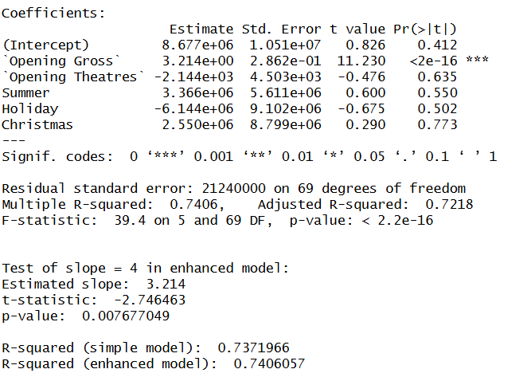
QUESTION 8
Aim:
To evaluate the effect of critics’ opinion on total U.S. box-office gross using all factors known after the opening weekend, and to quantify the monetary value of an improvement in critics’ score for a movie such as “Flags of Our Fathers.”
The following predictors were considered:
- Pre-production factors: Budget, COMEDY_DUMMY, MPAA_D, Sequel, Known Story
- Opening-weekend setup: Opening Theatres, Summer, Holiday, Christmas
- Opening-weekend outcome: Opening Gross, Critics’ Opinion
Variable Selection
An initial regression including all these predictors was estimated with Total U.S. Gross as the dependent variable. Using a 10 per cent significance level for variable selection:
- Null Hypothesis for each coefficient: The population coefficient is equal to zero (no effect on Total U.S. Gross).
- Alternative Hypothesis for each coefficient: The population coefficient is not equal to zero.
- Significance level for dropping variables: 10 per cent.
Variables with p-values greater than 0.10 were dropped from the model.

Dropped variables (p-value > 0.10):
- COMEDY_DUMMY
- Sequel
- Known Story
- Opening Theatres
- Summer
- Holiday
- Christmas
Retained variables (p-value ≤ 0.10):
- Budget
- MPAA_D
- Opening Gross
- Critics’ Opinion
Final Regression Model
The final model for Total U.S. Gross includes Budget, MPAA_D, Opening Gross and Critics’ Opinion. The estimated coefficients are approximately:
- Intercept ≈ −30.04 million dollars
- Budget coefficient ≈ 0.2586
- MPAA_D coefficient ≈ −11.14 million dollars
- Opening Gross coefficient ≈ 2.820
- Critics’ Opinion coefficient ≈ 590,800 dollars
Interpretation of key coefficients:
- Budget: Holding other variables constant, increasing the production budget by 1 dollar is associated with an increase of about 0.26 dollars in total U.S. gross. The p-value is less than 0.01, so at the 10 per cent significance level the Null Hypothesis that the budget coefficient is zero is rejected.
- MPAA_D (R-rating dummy): Holding other variables constant, R-rated movies are associated with about 11.14 million dollars lower total U.S. gross than non-R-rated movies. The p-value is about 0.034, which is below 10 per cent and 5 per cent, so the Null Hypothesis of no R-rating effect is rejected.
- Opening Gross: Holding other factors constant, each additional dollar of opening weekend gross is associated with about 2.82 dollars of total U.S. gross. The p-value is extremely small, so the Null Hypothesis that this coefficient is zero is strongly rejected.
- Critics’ Opinion: Holding budget, rating and opening gross constant, a one-point increase in critics’ score is associated with an increase of about 590,800 dollars in total U.S. gross. The p-value is very small (well below 1 per cent), so the Null Hypothesis that critics’ opinion has no effect is rejected at the 10 per cent and 5 per cent significance levels.
Overall, the model has a high R-squared (about 0.83), indicating that these four variables jointly explain a large share of the variation in total U.S. gross.
Prediction for “Flags of Our Fathers”
Using the final model, a prediction with a 95 per cent prediction interval was made for the movie “Flags of Our Fathers.”
- Point prediction for Total U.S. Gross: ≈ 57.65 million dollars
- 95% prediction interval: [21.51 million, 93.80 million]
This wide interval reflects the inherent uncertainty in movie performance even after accounting for budget, opening gross, rating and critics’ scores.
Value of a +10-Point Increase in Critics’ Opinion
From the final model, the slope for Critics’ Opinion is about 590,800 dollars per point. Therefore, a 10-point increase in critics’ rating is associated with:
- Point estimate of extra total U.S. gross: ≈ 5.91 million dollars
Using the standard error of the critics’ coefficient and the t-distribution, a 95 per cent confidence interval for this effect is:
- 95% confidence interval for extra gross from +10 points: [3.16 million, 8.65 million] dollars
Hypotheses for the critics’ effect (10-point increase):
- Null Hypothesis: A 10-point increase in critics’ opinion has no effect on expected Total U.S. Gross (expected change = 0).
- Alternative Hypothesis: A 10-point increase in critics’ opinion changes expected Total U.S. Gross (expected change ≠ 0).
- Significance level: 5 per cent.
Decision:
Since the 95 per cent confidence interval for the effect of a 10-point increase does not include zero, the p-value is less than 0.05 and the Null Hypothesis is rejected.
Managerial Conclusion:
Critics’ opinion has a strong and statistically significant impact on total U.S. gross even after controlling for budget, rating and opening performance. For a movie like “Flags of Our Fathers,” it would be financially reasonable to invest up to roughly 5–6 million dollars (and certainly up to the lower bound of the confidence interval) in activities that credibly improve critics’ scores by 10 points. Spending more than the expected additional revenue would not be financially justified on average.

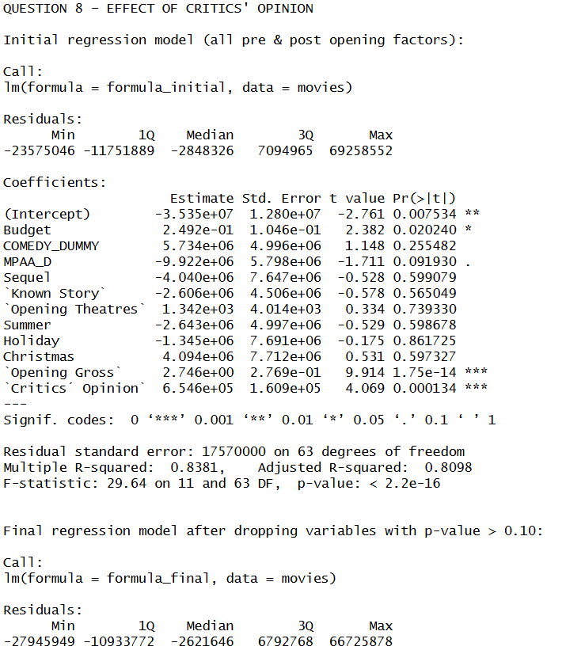
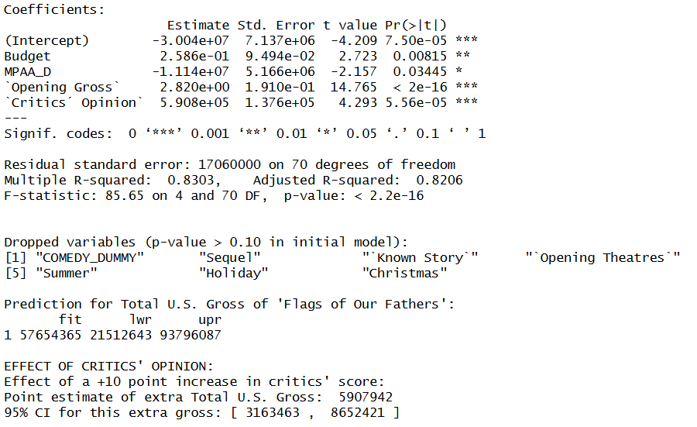

QUESTION 9
Aim:
To test whether critics’ opinions affect comedies differently than non-comedies, by including an interaction term between Critics’ Opinion and COMEDY_DUMMY in the regression for total U.S. gross. This directly addresses Griffith’s belief that critics’ reviews matter less for comedies.
A regression was estimated with Total U.S. Gross as the dependent variable and the following predictors:
- Budget
- MPAA_D
- Opening Gross
- Critics’ Opinion
- COMEDY_DUMMY
- Interaction term: Critics’ Opinion × COMEDY_DUMMY
Interpretation of the Interaction
In this model:
- The coefficient of Critics’ Opinion measures the effect of critics’ score on total U.S. gross for non-comedies (COMEDY_DUMMY = 0).
- The interaction coefficient measures how much this effect changes for comedies relative to non-comedies.
Hypothesis Test for the Interaction
The key question is whether the interaction term is significantly different from zero.
- Null Hypothesis: The population coefficient of the interaction term (Critics’ Opinion × COMEDY_DUMMY) is equal to zero. In other words, the effect of critics’ opinion on total U.S. gross is the same for comedies and non-comedies.
- Alternative Hypothesis: The population coefficient of the interaction term is not equal to zero. In other words, the effect of critics’ opinion on total U.S. gross differs between comedies and non-comedies.
- Significance level: 10 per cent.
From the regression output, the interaction term had:
- Interaction coefficient ≈ −228,179
- p-value ≈ 0.443
Decision and Reasoning
Decision (based on p-value vs significance level):
Since the p-value for the interaction term (about 0.443) is much larger than the 10 per cent significance level, the Null Hypothesis is not rejected.
Reasoning:
A high p-value indicates that the observed interaction estimate could easily arise from random sampling variation even if the true interaction effect were zero. There is no statistical evidence at the 10 per cent level that critics’ impact on box office differs between comedies and non-comedies.
Conclusion for Griffith’s Theory
Griffith’s theory suggested that critics’ reviews matter less for comedies than for other genres. In this regression, the interaction coefficient is negative (which would be consistent with a weaker effect for comedies), but it is not statistically significant.
Therefore, based on this sample and at a 10 per cent significance level:
- We cannot statistically prove that critics’ influence on total U.S. gross is weaker for comedies than for non-comedies.
- Griffith’s theory is not supported by this regression analysis.
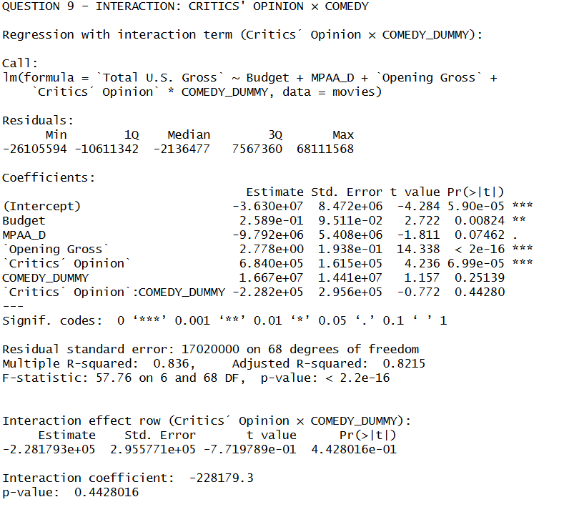

QUESTION 10
Aim
To evaluate Griffith’s claim that the presence of A-list actors (“star power”) rather than production budget is the true driver of total U.S. box-office revenue, and to determine how the regression coefficients should behave if his argument is correct.
Discussion
Griffith argued that higher gross revenue is not primarily the result of larger production budgets. Instead, he believed that movies with a higher number of A-list stars generate greater box-office performance. He also noted that the dataset available lacked a variable measuring star power, preventing him from testing the claim.
Let a new variable representing the number of A-list actors in a film (Star Power) were added to the regression model as we used in Question 9. The extended regression would take the form:
Total U.S. Gross = β₀ + β₁·Budget + β₂·MPAA_D + β₃·Opening Gross + β₄·Critics Opinion + β₅·COMEDY_DUMMY + β₆·(Critics × Comedy) + β₇·Star Power + error
Hypotheses
To support Griffith’s claim, the following would need to be true:
- Null Hypothesis (H₀): β₇ = 0 (Star Power has no effect on Total U.S. Gross)
- Alternative Hypothesis (H₁): β₇ ≠ 0 (Star Power has a statistically significant effect)
Required Behaviour of Coefficients
For Griffith’s conclusion to be supported by the regression results:
- The slope coefficient of Star Power (β₇) must be:
  - Positive, shows that each additional A-list actor increases expected total U.S. gross, without changing other factors.
  - Statistically significant at the chosen level (e.g., p < 0.05 or p < 0.10), allowing rejection of H₀.
- The coefficient of Budget (β₁) must:
  - Decrease in magnitude compared to the earlier model without Star Power.
  - Become statistically insignificant (p-value > significance level).
This would indicate that the previously strong positive effect of budget was driven by omitted variable bias—i.e., movies with large budgets tend to hire more A-list actors, and it is the stars, not the spending, that drive box-office success.
Conclusion
If the inclusion of Star Power causes the budget coefficient to weaken and lose statistical significance, while the Star Power coefficient becomes positive and significant, then the evidence would support Griffith’s view that star-driven casting, rather than production budget, is the true causal factor behind higher box-office performance.

CONCLUSION
This project applied statistical tools to evaluate key assumptions about box-office performance in the Hollywood Rules dataset. The findings show that movies in the $20–$100 million budget range generally earn returns above industry benchmarks, though profitability varies significantly across genres. Several common industry beliefs—such as the idea that opening weekend represents only 25% of total U.S. gross—do not hold statistically; opening performance contributes a much larger share.
Regression analyses highlight that budget, sequel status, opening theatres, opening gross and critics’ opinion all meaningfully influence total revenue, with opening weekend gross emerging as the strongest predictor. Critics’ reviews also have a measurable financial impact, and contrary to Griffith’s belief, this effect does not differ significantly between comedies and non-comedies.
Overall, the study demonstrates that data-driven analysis offers clearer guidance than traditional rules-of-thumb. Understanding the combined effects of opening performance, production factors and critical reception allows studios and investors to make more informed decisions in a highly uncertain industry.

